UPDATE (FEBRUARY 1, 2021)
Students are permitted to film in groups up to 5 outside while on-campus, and in groups up to 10 in approved campus buildings.

FOR CLARITY:
The initial number of 6 people outside on-campus was approved for a shoot that preceded the current stay-at-home order. We have now been advised that to comply with Ontario’s current emergency order, groups of no more than 5 are approved to meet on-campus outdoors. – Michael Darroch, Associate Dean, Academic, AMPD
- AND -
ACTRA TORONTO NOW REQUIRES ALL PRODUCTIONS TO INCLUDE PLANS FOR TESTING IN THEIR COVID-19 SAFETY PROTOCOLS
LINK TO ACTRA: https://www.actratoronto.com/
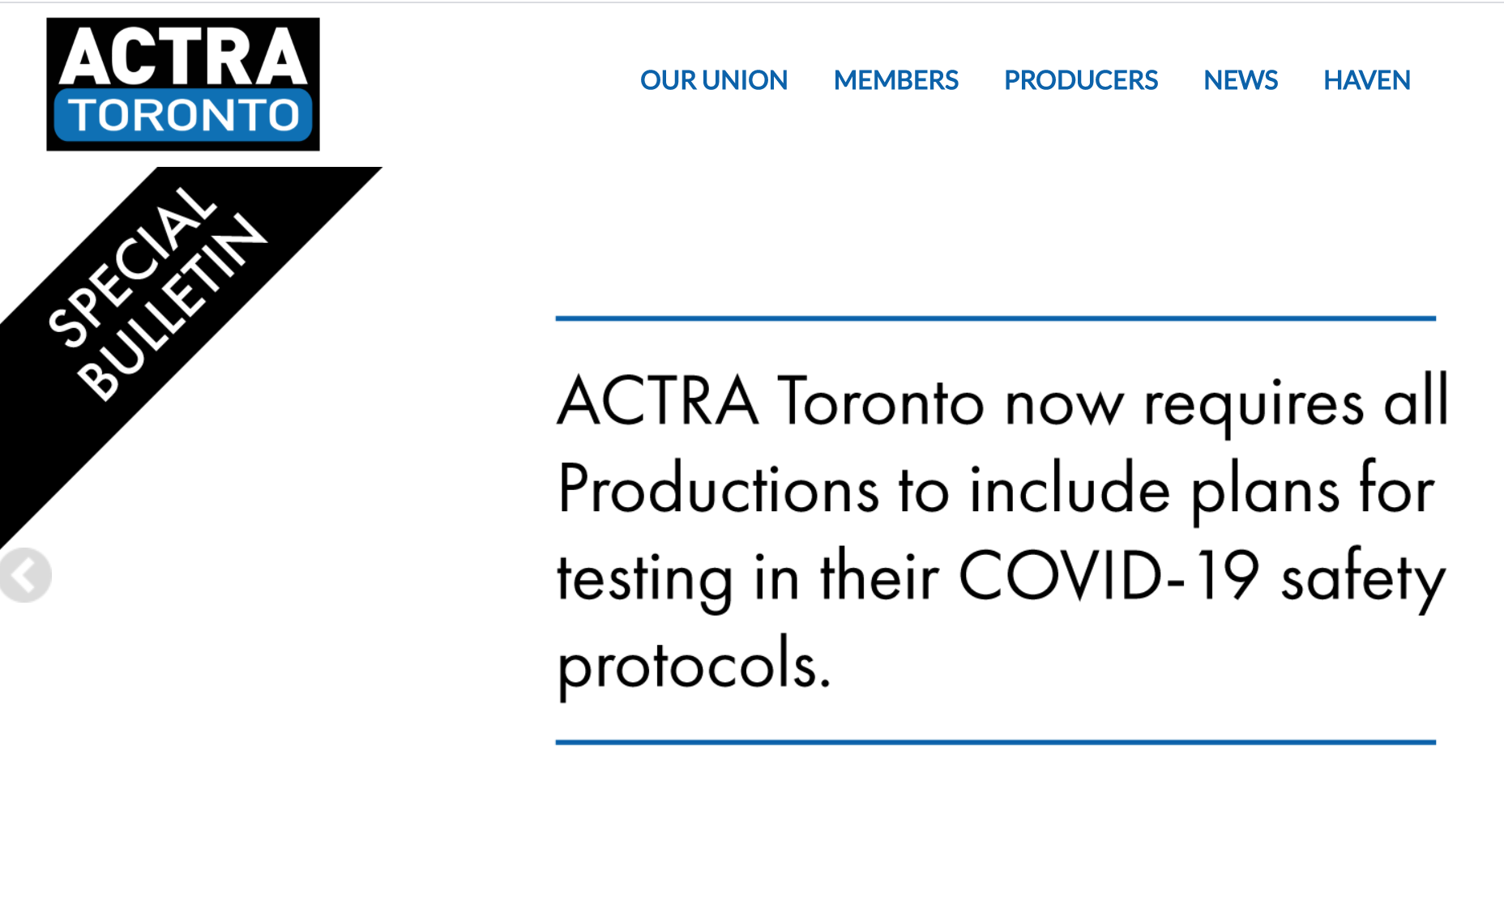
As of January 25th, Productions must have a testing plan in place for all performers and crew as per the Section 21 Film and Television Health and Safety Advisory Committee of the Ministry of Labour.
LINK TO (REVISED JAN. 25, 2021) SECTION 21: https://www.actratoronto.com/wp-content/uploads/2021/01/S21-Film-Television-COVID19-Guidance-Revised-Jan.25.21-Final.pdf
ACTRA has told us that they will assess student film productions on a case-by-case basis. Unlike industry productions, our student film sets do not include trained healthcare professionals.
YORK U STUDENTS, WHO WISH TO AUDITION ACTRA MEMBERS FOR PRODUCTIONS, NEED TO SUBMIT COVID-19 SAFETY PROTOCOLS, INCLUDING PLANS FOR TESTING, PRIOR TO CASTING. SUBMIT ALONG WITH REGISTRATION FORM AS INCLUDED IN ACTRA/YORK U AGREEMENT. https://film411.ampd.yorku.ca/cast-agreement-union/
ACTRA CONTACT INFORMATION: CINDY ANN RAMJATTAN, Business Representative, Film, Television & Digital Media, ACTRA TORONTO cramjattan@actratoronto.com
ACTRA will review materials and “aims” to turn around a decision within 48 hours.
- ACTRA might approve and give the go ahead for Casting.
- ACTRA might have questions, which could cause a delay. So students are encouraged to submit their Registration Form and COVID-19 Safety/Testing Protocols to ACTRA as soon as possible.
- ACTRA may reject the application. Students are advised to consult with their instructors regarding possible alternative plans.

Our YORK U student productions are to ensure the safety of all actors, both union and non-union, as well as Crew. SAFETY FIRST.
For further questions, please contact your Course Instructor.

